Stress Analysis Tool for Analysis of Thin-Walled Aircraft Structures

Submitted on November 28th, 2019

Submitted to:

Dr. Farjad Shadmehri

Christos Alexopoulos (40032962)

Tyler Cooke (40007617)

Sunera Paranagama (40015460)

# Introduction

The objective of this project was to develop an analysis tool to perform stress analysis on an arbitrary structure’s section and to solve a case study using the tool.

The tool was required to accept the following inputs:

* Number of stingers
* Area of each stringer
* Centroid coordinates of each stringer
* Thickness of skin between each 2 stringers
* Loads at section (𝑀𝑥, 𝑀𝑦, 𝑇, 𝑆𝑥, 𝑆𝑦)

Through the process of structural idealization, the inputted section is assumed into an arrangement of direct stress carrying booms and shear stress only carrying skin panels. The tool is to then provide the following outputs:

* Idealized booms’ area
* Centroid location of the idealized section
* Second moment of area (𝐼𝑥𝑥,𝐼𝑦𝑦,𝐼𝑥𝑦) of the idealized section
* Graphical representation of the idealized section and its centroid
* Direct (normal) stress at each boom
* Shear stress/flow in each skin panel due to direct shear (𝑆𝑥, 𝑆𝑦)
* Shear stress/flow in each skin panel due to torque (𝑇)
* Combined shear stress in each skin panel

The tool was utilized to solve a case study which involved analyzing a section of a proposed wing box to be used in a Bombardier Global 7000 aircraft. In fixed wing aircraft, the wing box is the primary load carrying structure of the wing. It forms the structural center of the wings and can function as an attachment point for wing components such as flaps and wing tip devices and can also serve as a fuel tank when designed in a “wet wing” configuration. When in flight, the lift generated by the aircraft opposes its weight leading to bending in the wing structure. Due to these reasons, the wing box is usually subject to various forces and moments both when in flight and when parked on the ground.

Figure Proposed wing box [1]

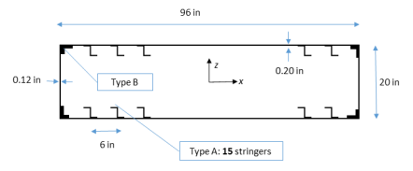

The following inputs where given from which a solution was to be found:

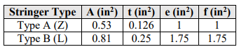

Table Stringer Specifications [1]

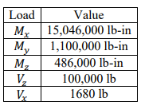

Table Critical loads at wing root [1]

In addition, the tool made the following assumptions when carrying out its computations:

* The horizontal and vertical applied shear loads and moments act at the centroid of the shape
* Structure section is symmetric about the x-axis
* Centroid is always at coordinate (0,0)
* The skin is thin enough that it can be assumed to be of zero thickness once the structure is idealized.
* Constant thickness on side panels and top panel across all stringers
* Stringers on top panel must all be at same height
* For closed section, cut is always made between stringer 1 and 2. At least one stringer between the two corner stringers is required.
* Can input 23 stringers between corner stringers 1 and 25.

# User Interface

Prior to using the tool, the user must know both the coordinates of all stringers in the structure’s cross-section, as well as the area of each of those stringers.

The tool consists of five worksheets. The first worksheet, “Program Rules”, consists of instructions on how the tool is to be operated. The remaining worksheets are split into separate pairs of worksheets for open and closed section with each pair consisting of a dedicated inputs and outputs sheet.

The two input sheets, “Closed Cell – Inputs” and “Open Cell – Inputs” allow users to input information on the loads on the section, skin thickness, and area and centroid of each stringer. As the tool supports symmetrical sections with up to 50 stringers, users can input the properties of the first 25 and the properties of the rest are populated automatically. The user should start entering properties of the stringers consecutively starting with stringer 1, but the last stringer manually entered must be stringer 25. Properties of any unused stringers in between can be left blank. In both Input sheets, only the cells shaded in blue accept an input.

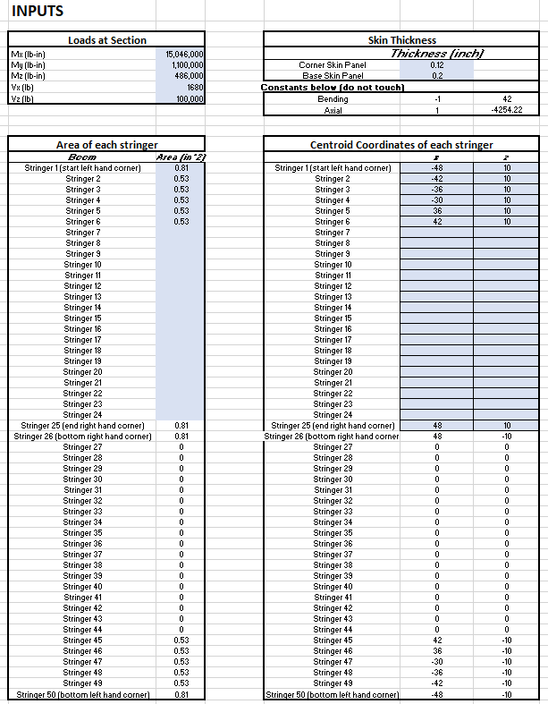The two output sheets, “Closed Cell – Outputs” and “Open Cell – Outputs” display the calculated resulting properties of the section along with a graphical representation of the position of the stringers. The output interface consists of four sections, displaying idealized boom are, section moments of area for the section and a graphical representation of boom positions and centroid .

Figure Closed Cell - Inputs screen

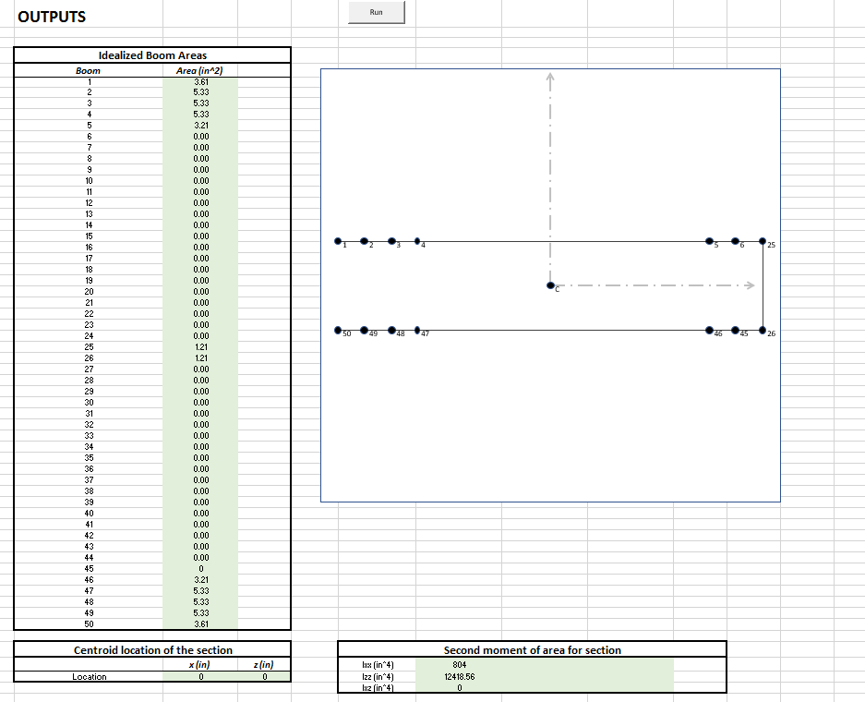

Figure Closed Cell - Outputs screen

The graphical representation is created with a macro that draws X and Z values from the respective inputs page to plot the position of booms within a specified area (the outer blue box in Figure 3.). Consecutive points are joined by lines to represent the skin of the section. A scaling feature automatically scales the plot according to the maximum X, Z values entered so that all points are always contained within the defined draw area. In addition, to prevent “empty” booms from being plotted (when not all of the 25 allowable stringer inputs are required), the code checks for the presence of boom area. Only booms with a boom area present are plotted. Apart from the booms and skin of the section, the position of the centroid is also drawn from the outputs worksheets and displayed.

Figure Graphical representation for a closed (left) and open(right) section

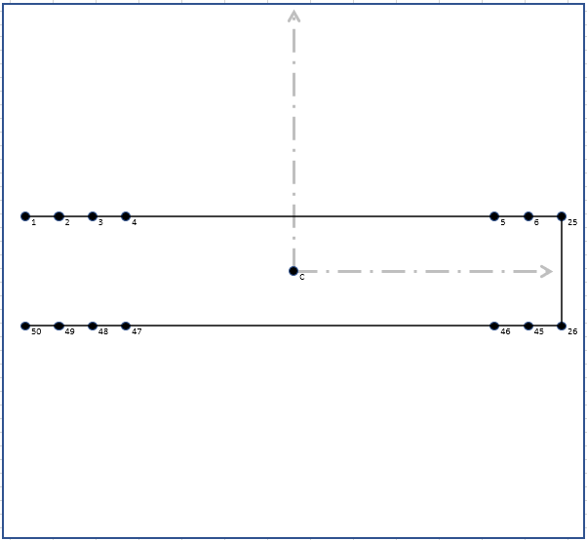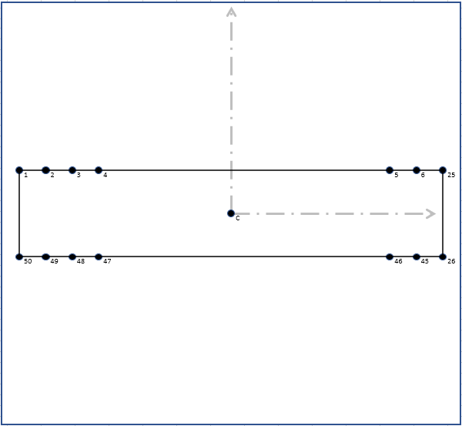

Refer to appendix A for VBA code

# Stress Analysis and Methods

Finding idealized boom areas:

Normal Stress:

The tool calculates the direct stress on each boom by considering the inputted moments about the X and Z axis (My, Vx, and Vz create shear in the section).

The following formulas where applied independently on Mx and Mz for each boom:

$${σ_{y}}_{M_{x}}=\frac{M_{x}}{{I_{xx}}_{Section}}z {σ_{y}}_{M_{y}}=\frac{M_{z}}{{I_{zz}}_{Section}} x$$

Where ${I_{xx}}_{Section}$ and ${I_{zz}}_{Section}$ are the sum of second moments of inertia of all booms about the X and Z axis respectively. $I_{xx}$ and $I_{zz}$ for each boom was calculated using:

${I_{xx}}_{Boom}=Bz^{2}$ ${I_{zz}}_{Boom}=Bx^{2}$

$z$ and $x$ are the perpendicular distances of the boom from the centroid with regard to the Z and X axis.

The net normal stress on each boom was then calculated by calculating the sum of stresses created by each moment:

$${σ_{y}}_{Total}={σ_{y}}_{M_{x}}+{σ_{y}}_{M_{z}}$$

The spreadsheet carries out the calculations as outlined by the above equations.

Refer to appendix B Direct/Normal Stress Calculation for excel formulas:

Formula B1: ${σ_{y}}_{M_{x}}=('Closed Cell - Inputs'!\$C\$4/\$H\$58)*S6$

Formula B2: ${σ_{y}}_{M_{z}}=('Closed Cell - Inputs'!\$C\$6/\$H\$59)*T6$

Where the inputted moment values are drawn from the Inputs worksheet and divided by previously calculated ${I_{xx}}_{Section}$ and ${I_{zz}}_{Section}$ values. This is then multiplied by $z$ and $x$ values respectively

Formula B3: ${I_{xx}}_{Boom}=(D65*(E65)^2)$

Formula B4: ${I_{zz}}_{Boom}=(D65*(ABS(F65))^2)$

Where the previously calculated boom area (column D) is multiplied by the respective $z$ and $x$ values drawn from the inputs worksheet.

Shear Flow:

This tool can compute the shear flow acting along adjacent skin panels in open and closed sections. The tool performs this computation according to the following steps:

* Finds the idealized boom areas
* Finds the sectional properties of the section (area, centroid, moments of area)
* Divides the vertical and horizontal shear loads by Ixx and Iyy respectively
* Begins by cutting the panel between booms 1 and 2 (top left corner), and assigning to it a shear flow of 0
* Finds the shear flow in the panels between boom n and boom n+1 according to the equations below.

$$q_{s}=(\frac{{-V}_{z}}{I_{xx}} \sum_{r=1}^{n}{B_{r}z_{r}}+ \frac{{-V}_{x}}{I_{zz}}\sum_{r=1}^{n}{B_{r}x_{r} )+ q_{s,0}}$$

$$q_{b1}=\frac{{-V}_{z}}{I_{xx}} \sum_{r=1}^{n}{B_{r}z_{r}}$$

$$q_{b2}=\frac{{-V}_{x}}{I_{zz}}\sum_{r=1}^{n}{B_{r}x_{r} }$$

$$q_{b}= q_{b1}+ q_{b2}$$

$$q_{s}= q_{b}+ q_{s,0}$$

Where:

$$B_{r}=the area of boom r$$

$$z_{r}=distance of boom area r from horizontal axis through the centroid$$

$$x_{r}=distance of boom area r from vertical axis through the centroid$$

$$q_{b1}=Basic shear flow due to applied vertical shear load$$

$$q_{b2}=Basic shear flow due to applied horizontal shear load$$

$$q_{s}=Total shear flow$$

$$q_{s,0}=Closed beam correction factor$$

The quantity ${ q}_{s,0}$ is found by summing the moments about the centroid due to each individual basic shear flow (qb) and dividing it by twice the enclosed area of the closed section. This quantity is then added to the basic shear flow to arrive at the total shear flow.

Example Excel code for various quantities:

Refer to appendix C Shear Stress Calculation for excel formulas:

**Closed sections:**

Symbols used in spreadsheet:

* Z = z coordinate of boom area
* X= x coordinate of boom area
* qb1= q basic due to vertical shear load
* qb2 = q basis due to horizontal shear load
* qb = combined shear flow due to qb1 and qb2
* qs = shear flow due to shear loads
* Qs = shear stress due shear loads
* Qt = shear stress due to torsional moment
* J = Torsional constant

*Formula C1:*

Vz is stored in cell C7 in the “Closed Cell-Inputs” spread sheet. Ixx is stored in cell H59 in the “Closed Cell-outputs spread sheet. Absolute references are made to each cell, that is the symbol “$” is placed in front of the row number and column letter in order to avoid referencing any other cells. The excel formula also indicates that if any number stored in column D is equal to 0, then the above ratio will be set to 0. This is to avoid calculating shear flows in panels that don’t exist. Similar code is used for Vx/Izz.

*Formula C2:*

The quantity qb1 is calculated for each panel. Each panel’s qb1 is stored in column M. The ratio Vz/Ixx is stored in column L. The distance of the boom from the horizontal centroidal axis z is stored in column G, and the area of the relevant boom is stored in column D. The values in columns L, G, and D are multiplied together, and added to the result in the previous cell. For example, when calculating qb23 (q basic between booms 2 and 3), the result in the previous cell would be qb12 (q basic between booms 1 and 2). A similar excel formula is used to calculate qb2, where the relevant quantities are referenced.

*Formula C3:*

The quantity Sxi is the elemental internal shear force due to the shear flow in panel r . It is the length of the panel multiplied by the basic shear flow. H8-H7 is the difference between the x-coordinates of adjacent booms, or the length of the panel. The quantities stored in column O are the q basic in each panel.

*Formula C4:*

The sum of the moments due to the internal shear forces in the skin panels is taken about the point where the horizontal centroidal axis intersects the line of action of the external applied shear force, in this case, the centroid. Added to this quantity is the sum of the moments due to the internal shear forces in the side skin panels is taken about the point where the vertical centroidal axis intersects the line of action of the external applied shear force, in this case, also the centroid.

*Formula C5:*

The sum of the moments in the skin panels is stored in cell R56. Dividing this number by 2(A) of the section gives qs,0.

*Formula C6:*

The shear flow is the sum of the basic shear flows and qs,0. To find the *shear stress*, qs is simply divided by the thickness of the panel in which its acting.

*Formula C7:*

The applied torsion T is the moment My given in the problem statement. Formula C7 gives the version of this formula below in excel. The torsional stress is labeled as Qt in the excel spreadsheet.

$$f=\frac{T}{2abt}$$

$$f=torsional shear stress$$

$$T=Applied torsion My$$

$$a=width of the top of the section$$

$$b=the height of the vertical panel$$

$$t=thickness of the given panel$$

The combined shear stress is found by adding the shear stress due to shear loads to the shear stress due to torsion.

**Opened sections:**

The open section beam is assumed to be a C-section beam with an opening on the left side, that is, between booms 50 and 1.

A similar procedure is used to compute the shear flow and shear stress in the panels of the section. However, it was not necessary to calculate qs,0. The total shear flow qs was taken as the combined basic shear flows.

The torsional shear stress was slightly more complicated for open section beams than for closed section beams. It was necessary to find a total torsional constant J.

$$J=\frac{1}{3}\sum{{bt}^{3}}$$

$$t=thickness of given skin panel$$

$$b=length of given skin panel$$

$$τ=\frac{Tt}{J}$$

# Conclusion

The final stress analysis values were consistent with what was expected. Symmetry about x-axis for stress and shear flow values could be seen, and the idealized boom areas and section area moments where logical. In addition, Torsion values for open cell where higher than for a closed cell. The shear stress and direct stress paths vary as expected as well, atarting at zero, peaking in the middle, and then back to zero.

# Appendices

Appendix A VBA Code:

*Sub Plot()*

*Dim p As Shape 'point*

*Dim Axis As Shape*

*Dim Xrange As Range*

*Dim Yrange As Range*

*Dim FullRnge As Range*

*Dim Xval As Double*

*Dim Yval As Double*

*Dim XvalOld As Double*

*Dim YvalOld As Double*

*Dim Xinit As Double*

*Dim Yinit As Double*

*Dim CenX As Double*

*Dim CenY As Double*

*Dim Acheck As Double*

*Dim MaxXY As Double*

*Dim S As Long 'number of stringers*

*Dim Label As String*

*Dim scle As Double 'scale*

*'independent x,y translate*

*Dim OtransX As Double*

*Dim OtransY As Double*

*Set FullRnge = ThisWorkbook.Worksheets("Open Cell - Inputs").Range("F14:G63") 'range for all x,y values*

*Set Xrange = ThisWorkbook.Worksheets("Open Cell - Inputs").Range("F14:F63") 'range for x values*

*Set Yrange = ThisWorkbook.Worksheets("Open Cell - Inputs").Range("G14:G63") 'range for y values*

*'Centroid range*

*CenX = ThisWorkbook.Worksheets("Open Cell - Outputs").Cells(4, 59).Value*

*CenY = ThisWorkbook.Worksheets("Open Cell - Outputs").Cells(5, 59).Value*

*'scale - find max value, divide by max wanted resolution size*

*MaxXY = MaxAbsR(FullRnge)*

*scle = (MaxXY / 300)*

*'shift origin*

*OtransX = 800 'pixels from left*

*OtransY = 400 'pixels from top*

*Worksheets("Open Cell - Inputs").Calculate*

*'delete existing points*

*For Each p In ThisWorkbook.Worksheets("Open Cell - Outputs").Shapes*

*If p.AlternativeText <> "Run" Then 'delete everything with out the text "Run"*

*p.Delete*

*End If*

*Next p*

*For Each Axis In ThisWorkbook.Worksheets("Open Cell - Outputs").Shapes 'delete existing Axis*

*If Axis.AlternativeText <> "Run" Then*

*Axis.Delete*

*End If*

*Next Axis*

*'draw axis*

*Set Axis = ThisWorkbook.Worksheets("Open Cell - Outputs").Shapes.AddShape(1, trans_xcoords(0, scle, OtransX) - 320, trans_ycoords(0, scle, OtransY) - 300, 650, 610)*

*Axis.Fill.ForeColor.RGB = RGB(255, 255, 255)*

*Axis.Line.Weight = 1.75*

*'Vertical Axis*

*ActiveSheet.Shapes.AddLine(0 + OtransX + 5, 0 + OtransY + 5, 0 + OtransX + 5, trans_ycoords(200, 1, OtransY) - 95).Select*

*With Selection.ShapeRange.Line*

*.BeginArrowheadStyle = msoArrowheadNone*

*.EndArrowheadStyle = msoArrowheadOpen*

*.Weight = 2.75*

*.Transparency = 0.75*

*.DashStyle = msoLineLongDashDot*

*.ForeColor.RGB = RGB(0, 0, 0)*

*End With*

*'Horizontal Axis*

*ThisWorkbook.Worksheets("Open Cell - Outputs").Shapes.AddLine(0 + OtransX + 5, 0 + OtransY + 5, trans_xcoords(200, 1, OtransX) + 95, 0 + OtransY + 5).Select*

*With Selection.ShapeRange.Line*

*.BeginArrowheadStyle = msoArrowheadNone*

*.EndArrowheadStyle = msoArrowheadOpen*

*.Weight = 2.75*

*.Transparency = 0.75*

*.DashStyle = msoLineLongDashDot*

*.ForeColor.RGB = RGB(0, 0, 0)*

*End With*

*ThisWorkbook.Worksheets("Open Cell - Outputs").Range("B1").Select*

*For i = 14 To 63 'set number of stringers, update these values when moving to new worksheet*

*Xval = ThisWorkbook.Worksheets("Open Cell - Inputs").Cells(i, 6).Value*

*Yval = ThisWorkbook.Worksheets("Open Cell - Inputs").Cells(i, 7).Value*

*Label = ThisWorkbook.Worksheets("Open Cell - Outputs").Cells(i - 8, 3).Value*

*Acheck = ThisWorkbook.Worksheets("Open Cell - Inputs").Cells(i, 3).Value*

*'create outer border*

*' Range("C8:L35").BorderAround _*

*' ColorIndex:=3, Weight:=xlThick*

*If Acheck <> 0 Then*

*'draw points*

*Set p = ThisWorkbook.Worksheets("Open Cell - Outputs").Shapes.AddShape(9, trans_xcoords(Xval, scle, OtransX), trans_ycoords(Yval, scle, OtransY), 10, 10)*

*p.Fill.ForeColor.RGB = RGB(0, 0, 0)*

*'add labels*

*Set p = ThisWorkbook.Worksheets("Open Cell - Outputs").Shapes.AddLabel(msoTextOrientationHorizontal, trans_xcoords(Xval, scle, OtransX) + 5, trans_ycoords(Yval, scle, OtransY), 100, 100)*

*p.TextFrame.Characters.Text = Label*

*If i = 14 Then*

*Xinit = trans_xcoords(Xval, scle, OtransX)*

*Yinit = trans_ycoords(Yval, scle, OtransY)*

*End If*

*If i > 14 Then*

*Set p = ThisWorkbook.Worksheets("Open Cell - Outputs").Shapes.AddLine(XvalOld + 5, YvalOld + 5, trans_xcoords(Xval, scle, OtransX) + 5, trans_ycoords(Yval, scle, OtransY) + 5)*

*p.Line.ForeColor.RGB = RGB(0, 0, 0)*

*p.Line.Weight = 1.75*

*p.Line.Transparency = 0.25*

*End If*

*XvalOld = trans_xcoords(Xval, scle, OtransX)*

*YvalOld = trans_ycoords(Yval, scle, OtransY)*

*End If*

*Next*

*Set p = ThisWorkbook.Worksheets("Open Cell - Outputs").Shapes.AddShape(9, trans_xcoords(CenX, scle, OtransX), trans_ycoords(CenY, scle, OtransY), 10, 10)*

*p.Fill.ForeColor.RGB = RGB(0, 0, 0)*

*Set p = ThisWorkbook.Worksheets("Open Cell - Outputs").Shapes.AddLabel(msoTextOrientationHorizontal, trans_xcoords(CenX, scle, OtransX) + 5, trans_ycoords(CenY, scle, OtransY), 100, 100)*

*p.TextFrame.Characters.Text = "C"*

*'comment in/out the 3 lines below to switch from open/closed section*

*' Set p = ThisWorkbook.Worksheets("Open Cell - Outputs").Shapes.AddLine(XvalOld + 5, YvalOld + 5, Xinit + 5, Yinit + 5)*

*' p.Line.ForeColor.RGB = RGB(0, 0, 0)*

*' p.Line.Weight = 1.75*

*' p.Line.Transparency = 0.25*

*End Sub*

*'X Coord translate function*

*Function trans_xcoords(x As Double, aScl As Double, aOtrans As Double)*

*trans_xcoords = (x / aScl) + aOtrans*

*End Function*

*'Y Coord translate function*

*Function trans_ycoords(y As Double, bScl As Double, bOtrans As Double)*

*trans_ycoords = (-y / bScl) + bOtrans*

*End Function*

*Function MaxAbsR(Dataa As Range)*

*Dim MaxVal1 As Double, MinVall As Double*

*MaxVal1 = WorksheetFunction.Max(Dataa)*

*MinVall = -WorksheetFunction.Min(Dataa)*

*If MaxVal1 > MinVall Then MaxAbsR = MaxVal1 Else MaxAbsR = MinVall*

*End Function*

Appendix B:

${σ_{y}}_{M_{x}}=('Closed Cell - Inputs'!\$C\$4/\$H\$58)*S6$

*Formula B1: Direct stress along the Y axis due to $M_{x}$*

${σ_{y}}_{M_{z}}=('Closed Cell - Inputs'!\$C\$6/\$H\$59)*T6$

*Formula B2: Direct stress along the Y axis due to $M_{z}$*

${I_{xx}}_{Boom}=(D65*(E65)^2)$

*Formula B3: Second moment of inertia of boom about X axis*

${I_{zz}}_{Boom}=(D65*(ABS(F65))^2)$

*Formula B4: Second moment of inertia of boom about Z axis*

Appendix C:

$$\frac{{-V}_{z}}{I_{xx}} =IF(D6=0,0,('Closed Cell - Inputs'!\$C\$7)/('Closed Cell - Outputs'!\$H\$59))$$

*Formula C1: Ratio of external vertical shear force to moment of inertia about horizontal centroidal axis*

$q_{b1}=IF(\$D\$7=0,0,M6+(-L6*G7*D7))$

*Formula C2: Basic shear flow in panel r due to external vertical shear force*

$$S_{Xi}=IF(H7=0,0,O7*(H8-H7))$$

*Formula C3: Shear force in x due to shear flow in panel r.*

$$Sum of moments=(P7*G7) +(Q7*H7)$$

*Formula C4: Sum of the moments about the centroid.*

$$qs,o =R56/(2*(\$H\$30-\$H\$6)*(\$G\$6-\$G\$55))$$

*Formula C5: Finding qs,o*

$$qs =IF(D6=0,0,O6+\$R\$57)$$

*Formula C6: Finding qs*

$$f =IF(D6=0,0,'Closed Cell - Inputs'!\$C\$6/(2*(\$H\$30-\$H\$6)*(\$G\$6-\$G\$55)*'Closed Cell - Inputs'!\$F\$6))$$

*Formula C7: Finding torsional stress*